

S.5 END OF TERM ONE 2024

STUDIO TECHNOLOGY (615/4)

2HRS

**INSTRUCTIONS**

* Attempt all questions
* Drawings and diagrams should be used where necessary and credit will be given for explanatory value.

1. (a) Define the following terms as used in art and design?
2. Art. (1mk)
3. Design. (1mk)
4. Studio. (1mk)
5. Studio technology. (1mk)

(b) Discuss the relevancy reasons for studying art and design in secondary schools? (6mks)

1. (a) Give the difference between a hue and intensity? (3mks)

(b) Mention down the five importance’s of color? (5mks)

1. (a) Explain the term studio technology? (2mks)

(b) Differentiate between three dimensional and two dimensional art? (2mks)

1. (a) Why is it important to sketch before starting making an article? (6mks)
2. (a) Define the term element of art and design? (1mk)

(b) Using illustrations, explain the six elements of art and design? (6mks)

1. (a) Write short notes about the following words used in art?
2. Positive space (1mk)
3. Negative space (1mk)

(b) Discuss the different ways on how space can be created in an art work? (4mks)

1. (a) List the materials and tools that can be used in art room? (4mks)

(b) Mention down the precautions that can be followed before entering an art room? (8mks)

1. (a) Explain down the importance of principles of art and design to an artist? (4mks)

(b) Using illustrations, explain the three types of balance? (6mks)

1. (a) Mention down the challenges associated with art and design making? (7mks)
2. Using illustrations, explain the four types of line? (4mks)

xxENDxx



S.5 EN5 OF TERM ONE EXAMINATIONS 2024

615/3 (Graphic design)

5hrs and 30 min

INSTRUCTIONS

* Drawing instruments; tracing paper and similar aids are allowed.
* You are required to spend the 2hrs and 15min doing the following

1. Reading and selecting both task and materials
2. Sketching
3. Transfer if necessary

TASK

1. In a space of 18cm X 24cm, design a logo for Tendo House of Plastics.it is a company that deals in the production of plastic cups, chairs. Use not more than three colors.
2. In dimension of 18cm X 24cm, design a label for Mudunga mango juice. This juice is a registered product of Wava Company Limited. Use not more than three colors of your choice.
3. In an area of 22cm X 32cm and using a repeated pattern, design a wrapping paper in which a company is called Movit Herbal Soap made from natural extracts (herbal). Use not more than four colors.
4. Within a dimension of 26cm X 32cm and in only three colors, design a signpost for Daff Grande Hotel. Located in Mukono P.O Box 276Mukono. Tel; +256 70834329, Email [daffgrandehotel@gmail.com](mailto:daffgrandehotel@gmail.com) .

We offer free Wi-Fi, good meals, good accommodation, and conference hall.

XXENDXX



S.5 END OF TERM ONE EXAMINATIONS 2024

**(Study of living person and imaginative composition in color)**

615/2

**INSTRUCTIONS**

* ATTEMPT ONLY ONE SUBJECT

**SUBJECTS**

1. Imagine during resurrection day.
2. It rained cuts and dogs.
3. During the school assembly.
4. Face to face with the ghost.
5. Students in the library.
6. Two friends adolescent ladies sharing sugarcane under the tree
7. A story that ended into a drama.
8. A helpless woman.

XXXENDXX



S.4 END OF TERM ONE EXAMINATIONS 2024

ART AND DESIGN

PAPER ONE (Art history and studio technology)

**INSTRUCTIONS**

* This paper comprises of two parts;

Part A; History of Art

Part B; Studio technology (theory)

* Attempt only two questions. From Either/OR from A and B.

PART ‘A’ Art history (theory)

1. Uganda government has received financial support from one of its partners. The support intended to renovate one of the sports stadiums in the country so as to prepare for the coming AFCON host in East Africa.

Recently, the contractors who had been given this task visited the ancient buildings of Greece and Rome. They appreciated buildings which were created as early as the 17th century and are still strong and attractive to date.

The contractors were told that architectural art keeps evolving and they now propose to borrow some of the knowledge and practice they got from the Greek and Rome buildings to improve on the strength and beauty of the stadium.

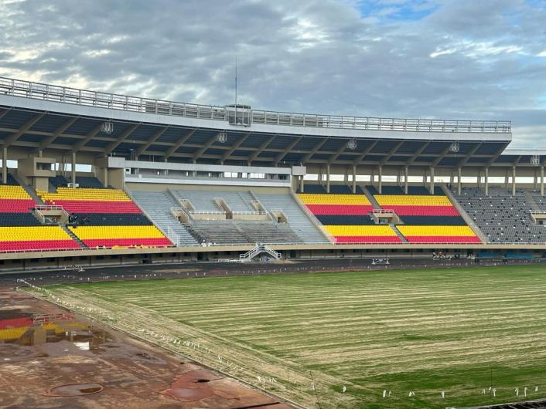

TASK

Assuming you are one of the contractors to renovate the sports stadium in Uganda, explain the architectural components you would borrow from ancient Greek and Roman artists to beautify Namboole stadium walls.

1. During the ancient Egyptian architecture, they built their pyramids, tombs, temples and palaces out of stone. Apart from the pyramids, the buildings were well decorated with paintings, curved stones images, hieroglyphs and three dimensional statues. This will create a generation which will know its origin. This means loss of original knowledge and skills developed by fore fathers.

TASK

Basing on your understanding of ancient Egyptian art and civilization, create a painting or drawing that shows the cultural practices of your own tribe. Indicate a brief write up about your art work and its subject matter.

PART “B” STUDIO TECHNOLOGY

1. There is a youth club in your sub county called “INSPIRATIONS”. The club empowers the youth with values and skill to become responsible citizens. They often hold meetings and provide counseling services to students as well as teaching them different skills in carpentry, cooking, tailoring, and weaving.

The club would like to be known by different audiences in the region for their impact to be felt.

TASK

Using colors of your choice design an identification symbol for this club.

1. A community hall has been set up at the sub-county. The hall is meant to serve various purposes such as meetings and wedding ceremonies.

A committee has been set up to procure curtains for the hall with a focus on the use of locally available motifs for the textile.

TASK

As a designer, create a sample repeated unit to be presented for the bid.

XXXENDXXX